EXTRACTION OF DEGRADED TREES ALONG A ROADSIDE USING NDVI TO HELP REDUCE ROUTINE MAINTENANCE COSTS IN GHANA

Ernest Akwasi APRAKU*¹, Latif SUBOI ² and Andrew KUTTIN-MENSAH³, Mitsuharu TOKUNAGA⁴

¹Graduate Student, Department of Civil and Environmental Engineering
Kanazawa Institute of Technology, Japan
Email: ernestapraku@ymail.com

²Graduate Student, Department of Civil and Environmental Engineering
Kanazawa Institute of Technology, Japan
Email: latifsuboi@gmail.com

³Graduate Student, Department of Civil and Environmental Engineering
Kanazawa Institute of Technology, Japan
Email: c6202114@st.kanazawa-it.ac.jp

⁴Professor, Department of Civil and Environmental Engineering
Kanazawa Institute of Technology, Japan
Email: mtoku@neptune.kanazawa-it.ac.jp

KEYWORDS: Roadside trees, Near-infrared Camera, Remote Sensing, NDVI, Maintenance
ABSTRACT: Roadside trees play a significant role in enhancing visual appeal, environmental sustainability, and, most notably, the safety of transportation networks. The degradation of trees along roadways poses a significant challenge to the maintenance efforts of transportation authorities worldwide, including Ghana. These degraded trees not only compromise the aesthetic appeal of road networks but also contribute to safety hazards and increase routine maintenance costs. This paper aims to explore the research conducted by Tokunaga (2020), which focuses on the extraction of degraded trees using the Normalized Difference Vegetation Index (NDVI) to aid in reducing routine maintenance costs along roads in Ghana. The findings from this research seek to integrate remote sensing technologies with traditional field surveys to enable a comprehensive assessment of tree degradation. This will aid decision-makers in developing long-term maintenance strategies and provide them with a cost-effective and data-driven approach to mitigate the adverse effects of degraded trees on routine maintenance, aesthetic value, and most importantly, safety. Finally, we discuss some of the challenges that need to be addressed to enable a fully operational and cooperative system to be adopted.

1. INTRODUCTION:

1.1 Background:

Roads are critical to economic development and growth and bring significant social benefits in all developing countries. They are of immense importance to make a country grow and develop. For reasons like these, roads are the most important public assets for developing countries like Ghana. Maintaining the roads has become a critical aspect of managing the assets. In developing countries like Ghana, where budgets are constrained, it becomes essential that road agencies thoroughly inspect the road conditions before decisions are taken in any aspect of managing the asset. Maintaining the integrity and safety of road networks is a continuous challenge for transportation authorities in Ghana. One of the significant issues the local road management agencies face is the degradation of trees along roadways, which compromises the landscape's visual appeal, contributes to safety hazards, and escalates routine maintenance costs. Roads are critical to economic development and growth and bring significant social benefits in all developing countries. They are of immense importance to make a country grow and develop. For reasons like these, roads are the most important public assets for developing countries like Ghana. Maintaining the roads has become a critical aspect of managing the assets. In developing countries like Ghana, where budgets are constrained, it becomes essential that road agencies thoroughly inspect the road conditions before decisions are taken in any aspect of managing the asset. Roads are critical to economic development and growth and bring significant social benefits in all developing countries. They are of immense importance to make a country grow and develop. For reasons like these, roads are the most important of all public assets for developing countries like Ghana.
Maintaining the roads has become a critical aspect of managing the assets. In developing countries like Ghana, where budgets are constrained, it becomes crucial that road agencies thoroughly inspect the road conditions before decisions are taken in any aspect of managing the asset. Like many other countries, Ghana grapples with the detrimental impacts of degraded trees lining its main road corridors. Often subjected to environmental stressors and human-induced disturbances, these trees exhibit declining health, such as sparse foliage, dead branches, and reduced vitality. As they become more susceptible to damage, these trees pose potential risks, including falling branches or complete collapse, leading to road blockages and endangering road users.
The escalating routine maintenance costs associated with managing degraded trees place a considerable financial burden on transportation authorities in Ghana. Traditional maintenance practices, such as periodic pruning, tree removal, and clearance operations, require significant resources and workforce. However, these maintenance efforts may only yield optimal results with accurate and efficient means of identifying and prioritizing degraded tree areas and can lead to resource wastage.
Currently, in Ghana, no prior inspections are done to identify trees that appear to be deteriorating along the road corridors. Trees along the roads are all cut down without determining which ones have significantly deteriorated. This activity costs the country lots of funds, time, and effort.

1.2 Related Works

Researchers have explored innovative approaches that combine advanced remote sensing technologies to address these challenges. One such approach involves utilizing the Normalized Difference Vegetation Index (NDVI) to assess vegetation's health and condition along roadways. The normalized difference vegetation index (NDVI), a measure of vegetation growth and coverage, is frequently used to define the spatiotemporal aspects of land use land cover, including the percentage of vegetation coverage(Konda et al. 2018). Several methods for remote sensing vegetation have been developed, most of which rely on the reflectance qualities of leaves in visible and infrared wavelengths—because of chlorophyll and carotenoids, high leaf pigment absorption and low reflectance occur in the visible range 0.4-0.7 μm, also known as photosynthetically active radiation (PAR). Water spectral absorption occurs in the mid-infrared wavelengths between 1.1 and 2.5 μm, with minimal absorption and significant levels of spectral reflectance due to leaf scattering mechanisms(Birky 2001).

1.3 Research Contributions of this Work

The main contributions of this work are two-fold. First, we explore the research conducted by Tokunaga (2020), which focuses on extracting degraded trees using the Normalized Difference Vegetation Index (NDVI) to aid in reducing routine maintenance costs along roads in Ghana. It is envisioned to replace the traditional method in Ghana of no prior inspections for cutting down roadside trees. The study's primary objective was to develop a data-driven and cost-effective approach for identifying and prioritizing areas with degraded trees, enabling transportation authorities in Ghana to optimize their routine maintenance efforts and allocate resources more efficiently. Secondly, the discussion and analysis of the findings will shed light on the practical implications of using NDVI-based approaches for tree management along roadways in Ghana and also summarize the key challenges, takeaways, and potential avenues for future research in this critical domain of road infrastructure management.
2. METHODOLOGY:

2.1 Overview of Remote Sensing Technology

Remote sensing gives crucial data about things at or near the earth's surface and the atmosphere based on radiation reflected or emitted from objects or areas in multiscale and multitemporal techniques. Using satellite or airborne sensors, remote sensing techniques collect data about a specific object or area. As a result, they are determined by their physical, chemical, biological, and geological features. Sensors installed on a platform (specifically, satellite, aerial, or unmanned airborne systems) above the earth's surface measure and record electromagnetic radiation. Sensors can be installed anywhere from a few hundred meters above the earth's surface (for example, high-resolution multispectral and hyperspectral imagers, light detection and ranging (LiDAR), and radar systems) to hundreds (or even thousands) of kilometers (for example, orbital satellites). Data collecting methods for remote sensing might be passive or active. Passive sensors (for example, spectral imaging) detect natural radiation emitted or reflected by the object or area under observation. Active sensors have their energy source, which is emitted in the direction of the object (for example, radar), and the reflected signal is detected (Chaminé et al. 2021).
Remote sensing technology is critical in environmental monitoring, resource management, disaster response, scientific research, and many other industries that require information from remote or inaccessible regions. It provides a low-cost, non-invasive method of collecting relevant data for a wide range of applications.

2.2 Remote Sensing Techniques

2.2.1 Characteristics of Electromagnetic Waves

Electromagnetic waves are reflected and emitted by all stuff. The intensity of that reflection and radiation is determined by the wavelength of the entering electromagnetic wave as well as the target material. The human eye perceives reflections of electromagnetic waves in the visible light band (0.4-0.7μm). Plants seem green because the reflectance at 0.5μm, which humans perceive as green, is higher than in other visible light bands. Conversely, plants have a maximum reflectance of roughly 1μm, which is unidentifiable to human sight. Plants are distinguished in the near-infrared region (Tokunaga 2020).
The range of electromagnetic radiation is summarized by wavelength or frequency by the electromagnetic spectrum (Figure. 1).
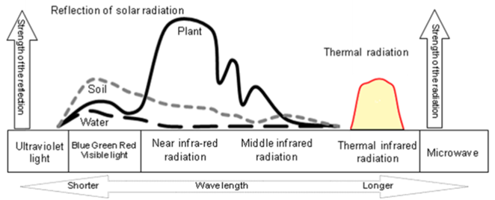
Figure 1 Electromagnetic spectral bands and reflection/radiation characteristics

2.2.2 Spectral reflectance properties of plants

The spectral reflectance (reflectance at each wavelength) in the near-infrared region allows for identifying tree species and assessing growth rate. In other words, it implies that the state of plants can be diagnosed using the wavelength range of 0.9 to 1.0μm, which cannot be validated visually.

2.2.3 Normalized Vegetation index (NDVI)

Vegetation indices have been used as measures of plant activity in earlier research, and several have been documented. NDVI was developed to assess the state of vegetation by utilizing the features of near-infrared wavelengths for plants. NDVI values vary from 1 to 1, regardless of whether radiance, reflectance, or DN are used as input. In other words, the greater the NDVI values, the more substantial implications for vigorous vegetation greenness. Using reflectance is very helpful in reducing the effect of scattered radiation (Jones and Vaughan 2010).
Mathematically, NDVI is described as follows:

$$N_{DVI}=\frac{N_{IR}NIR-R_{ed}Red}{N_{IR}NIR+R_{ed}Red}$$

Where $N_{DVI}$ is defined as the Normalized Difference Vegetation Index, $R_{ed}$ is the measure of reflectance in the red band (visible) region and $N_{IR}$ is the measurement of reflectance in the NIR region.

2.2.4 Extraction Procedure for Degraded Trees

The processes are summarized in the Figure 2 below;

Figure 2 Summary of extraction procedure

3. NDVI METHODS APPLICABLE TO ROAD SIDE TREE ASSESSMENT
3.1 Preliminary Experiment to determine NDVI
To collect data, a digital camera (Canon PowerShot S100) was used as a near-infrared camera with the infrared cut filter removed to allow near-infrared photography. Trees were examined from a moving trolley in this experiment to clone the procedure to be done on the road. The videos were filmed in Full HD using the camera mounted on the tripod and aimed onto the trees as shown in Figure 2. To avoid loss in capturing all the whole of trees, a series of still images were not used since, depending on the speed of the trolley or car, the shutter speed could not be reached in time, resulting in a loss in capturing the trees. As illustrated in Figure 2, five comparable conifers were lined up, and trees C and D were injured and forcibly withered. A near-infrared camera mounted on the dolly was utilized to film the process regularly until the wilting was confirmed by eye inspection while moving the trolley. This observation was done from mid-May to early July.
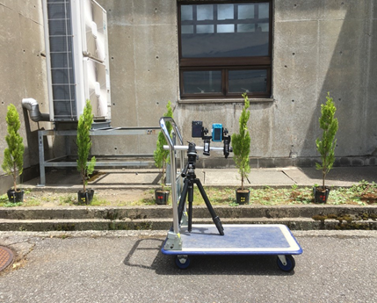
E
D
C
A
B
Figure 3 Experimental set-up to observe NDVI from a trolley
The NDVI averages for each block were derived by dividing the frames into 13×4 (138×270 pixels per block) and extracting the frames with conifers from the videos captured. The target frames were extracted and the blocked NDVI values were compared. The extraction process generally involved the automatic extraction of the frames, geometric correction of the frames, and blocked NDVI was then calculated (Tokunaga 2020).
Figure 3 shows the NDVI progression for each conifer. A and B recorded strong NDVI readings, indicating healthy trees. The degraded trees' C and E recorded values were lower than the A and B values. However, the healthy tree D followed the same pattern as the degraded tree. This is because D originally had a modest number of leaves and was not thick. As a result of the background of leaf gaps, the NDVI was judged to be low. This indicated that applying to trees with few leaves will be challenging. This preliminary experiment proved that separating healthy trees from degraded ones was possible.

Figure 4 NDVI transitions

3.2 Roadside Tree Observation Strategy
3.2.1 Observation System
The car will be equipped with a near-infrared camera to observe vegetation on the side of the road at a steady speed of 20 km/h. The road corridor will be observed once a month for a period of months to compare vegetation indices to determine the weak trees to aid road authorities in optimizing routine maintenance practices. 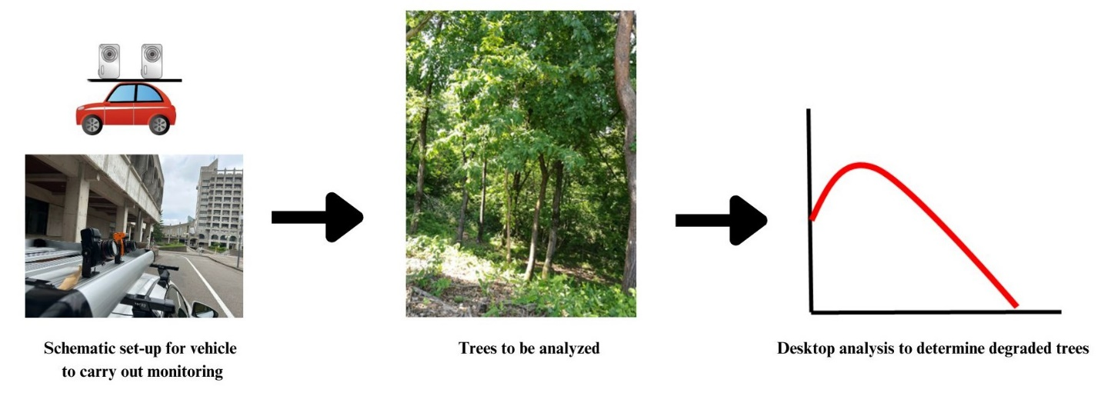

From videos captured, the extraction and NDVI for the trees will be determined as described in the previous section.

4. CHALLENGES AND OPPORTUNITIES:

4.1 Extraction of corresponding images taken at different times

Changes in vegetation are obtained from differences in images taken at the exact location at different times. Currently, only image data is searched for corresponding images, which propagates errors. Adding location information to images and acquiring satellite positioning information with centimeter or sub-meter accuracy to images will help alleviate this challenge.

4.2 Cost analysis

To ensure informed decision-making and insights into the cost-effectiveness and long-term viability of NDVI-based tree monitoring in enhancing road safety and environmental sustainability, a comprehensive cost analysis comparison between traditional methods and the innovative use of NDVI to extract debilitated trees along roadsides must be conducted. This will provide a structured framework for evaluating the economic implications of adopting NDVI-based tree monitoring techniques. We plan to include critical steps in our data collection: existing maintenance costs, categorization of expenses, analysis over defined timeframes, assessment of benefits, cost-benefit analysis, sensitivity analysis, and provision of recommendations.

4.3 Camera shortcomings

This is a simple step that can make a big difference in the processing stage. Future research into improving image quality is likely to involve the use of higher-resolution fixed-lens cameras, as well as finding ways to improve camera stabilization during flight, possibly through the use of miniaturized gyro-stabilized gimbal systems.

5. CONCLUSION:
One of the most valuable and essential resources in Ghana is the roads. Maintaining a safe and effective road system is crucial. Routine maintenance costs associated with managing degraded trees place a considerable financial burden on transportation authorities in Ghana. Traditional maintenance practices currently in practice require significant resources and a workforce. Using the proposed remote sensing technique offers the potential for road authorities to make tremendous savings on already constricted budgets. Although there may be some difficulties in adopting the technique, the low cost and operational flexibility offered by adopting this technique provide unique advantages compared with traditional methods and reduce the number of healthy trees being cut down in the traditional method.

ACKNOWLEDGEMENT:
The authors would like to express their appreciation to the Japan International Cooperation Agency (JICA) for their support through the Road Asset Management Platform (RAMP) and the Kanazawa Institute of Technology (KIT) for supporting the research.

CONFLICTS OF INTEREST:
The authors declare no conflict of interest.

REFERENCES:
Birky, Alicia K. 2001. “NDVI and a Simple Model of Deciduous Forest Seasonal Dynamics.” Ecological Modelling 143 (1–2): 43–58. https://doi.org/10.1016/S0304-3800(01)00354-4.
Chaminé, Helder I., Alcides J.S.C. Pereira, Ana C. Teodoro, and José Teixeira. 2021. “Remote Sensing and GIS Applications in Earth and Environmental Systems Sciences.” SN Applied Sciences 3 (12): 1–3. https://doi.org/10.1007/S42452-021-04855-3/METRICS.
Jones, Hamlyn, and Robin Vaughan. 2010. “Remote Sensing of Vegetation: Principles, Techniques, and Applications - Hamlyn G Jones, Robin A Vaughan - Google Books.” 2010.
Konda, Venkata Giri Raj Kumar, Venkatesh Reddy Chejarla, Venkata Ravibabu Mandla, Vani Voleti, and Nagaveni Chokkavarapu. 2018. “Vegetation Damage Assessment Due to Hudhud Cyclone Based on NDVI Using Landsat-8 Satellite Imagery.” Arabian Journal of Geosciences 11 (2): 1–11. https://doi.org/10.1007/S12517-017-3371-8/FIGURES/7.
Tokunaga, M. 2020. “Extraction of Debilitated Trees along the Road by Blocked NDVI.” In International Archives of the Photogrammetry, Remote Sensing and Spatial Information Sciences - ISPRS Archives, 43:209–14. International Society for Photogrammetry and Remote Sensing. https://doi.org/10.5194/isprs-archives-XLIII-B3-2020-209-2020.

